Assignment 13

2.? Problem Statement

Read the following data set:

https://archive.ics.uci.edu/ml/machine-learning-databases/adult/adult.data

Task:

1. Create an sqlalchemy engine using a sample from the data set

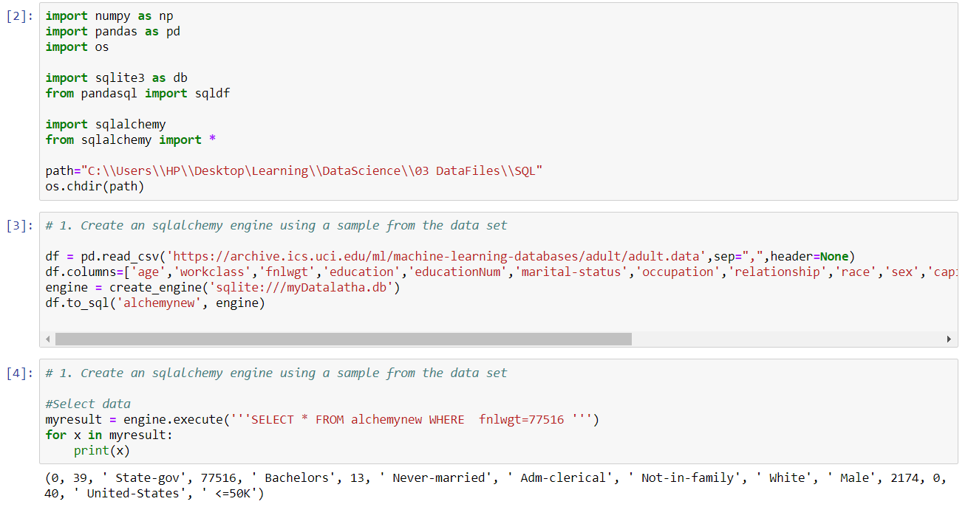

1. Write two basic update queries

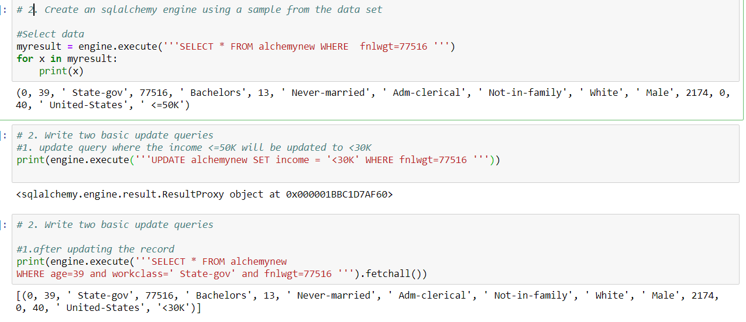

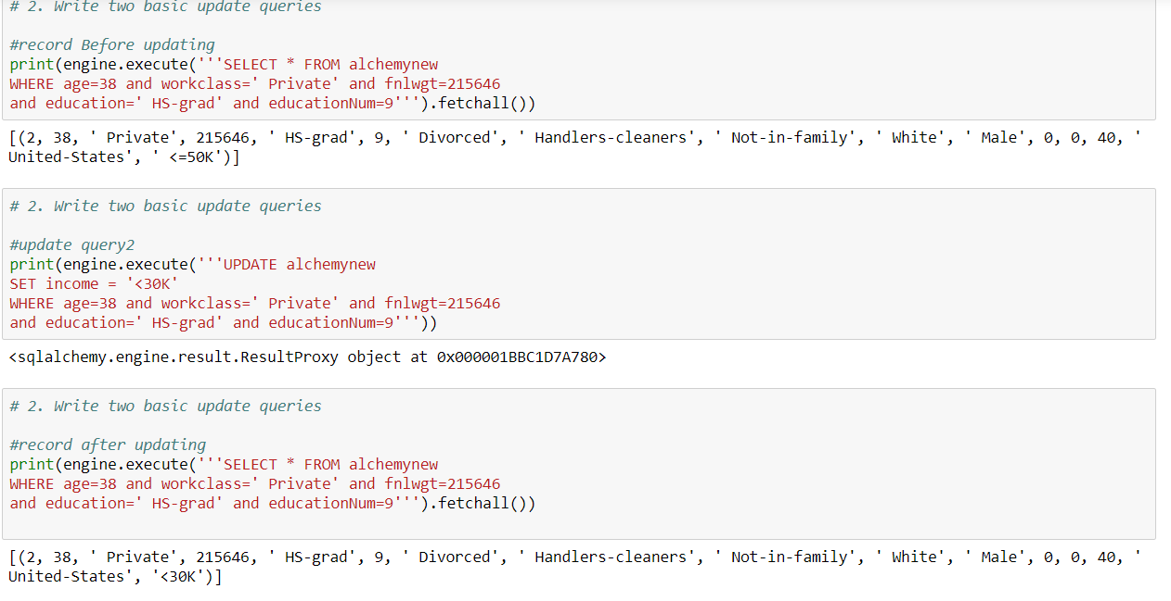

1. Write two delete queries

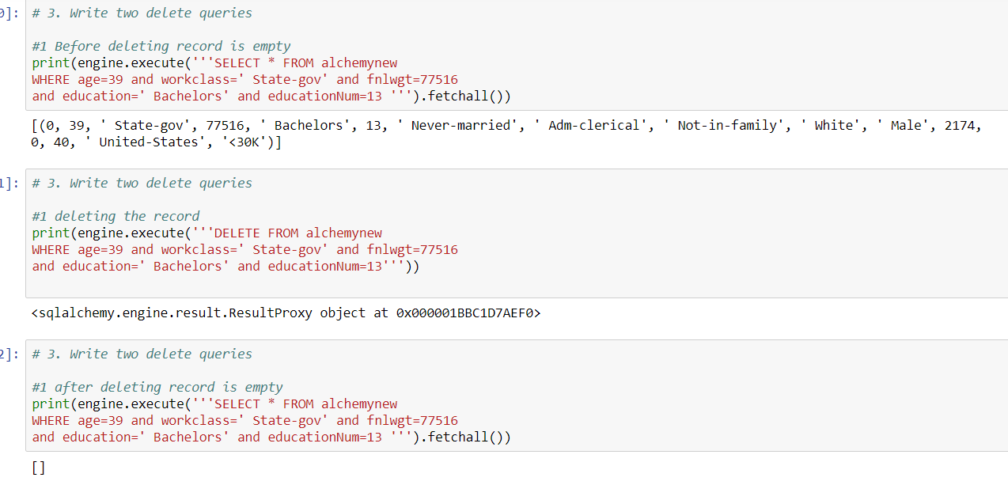

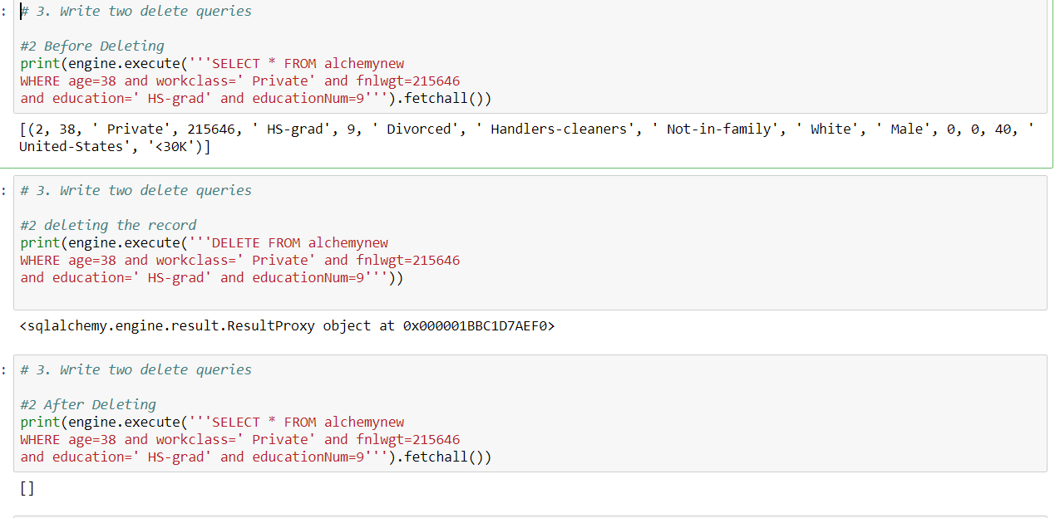

1. Write two filter queries

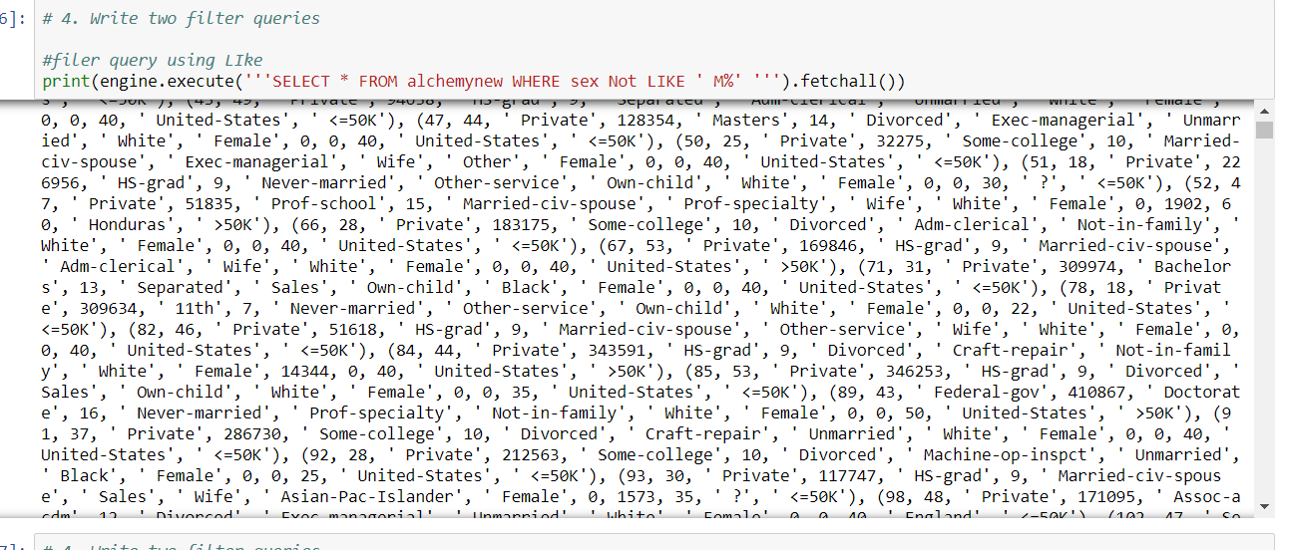

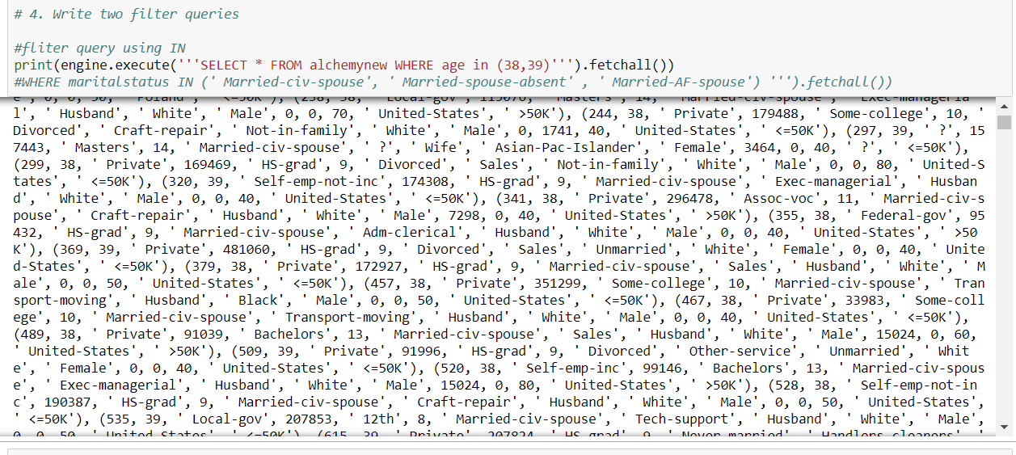

1. Write two function queries

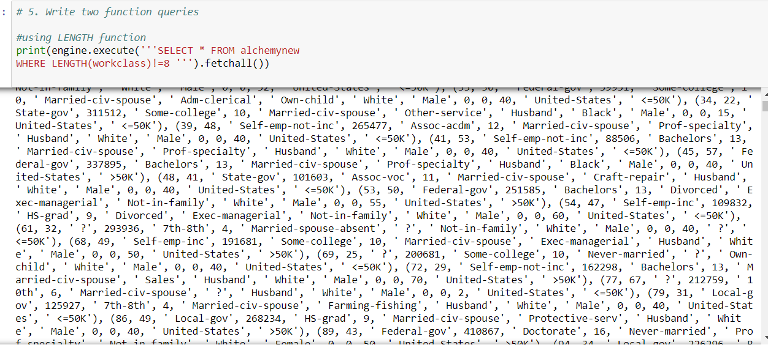

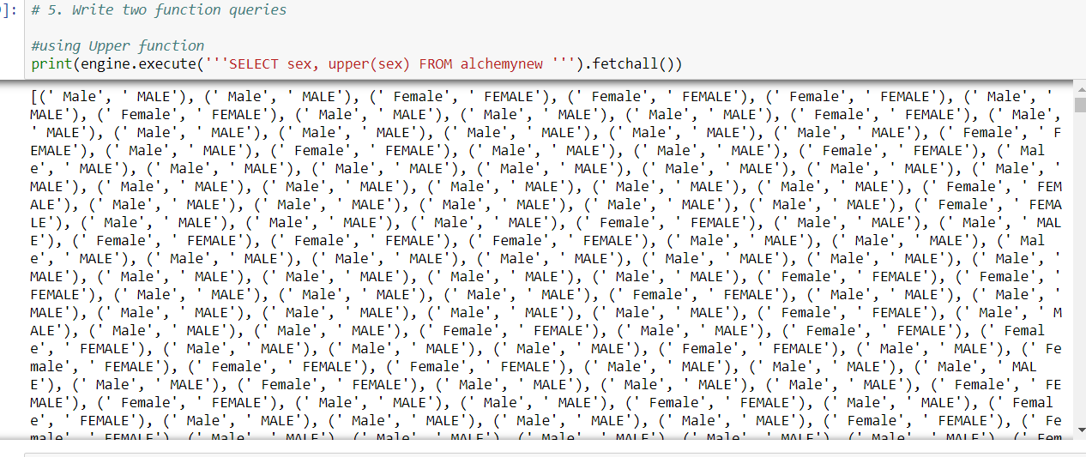

3. Expected Output

Note: Solution submitted via github must contain all the source code and output.